PRO URINE TESTING
Please read through these instructions before starting the collection process.

Chain of Custody important procedure to ensure collection of urine samples is done correctly. If paperwork or process is done improperly, enforcement of a failure can be put in jeopardy.

*Note: additional fees will be assessed by the lab when paperwork is submitted incorrectly.

Who IS TESTED?
Pro Show:
- Top 3 cash prize recipients.

Random Athletes:
- As directed by the OCB or event promoter.

IMPORTANT!
- Athlete must be escorted ALONE directly from stage to collection area.
- Athlete cannot bring anything into the restroom.
- Complete the entire process below 1 athlete at a time.
- Do not complete ANY OF THE paperwork in advance.
- ATHLETEs should be offered a bottle of water to drink WHEN they step off stage.
- AThletes should be given up to 2 hours to provide a sample. if AN athlete has difficulty, cannot provide a sample or leaves without providing a sample, alert the promoter immediately.

SAMPLE A 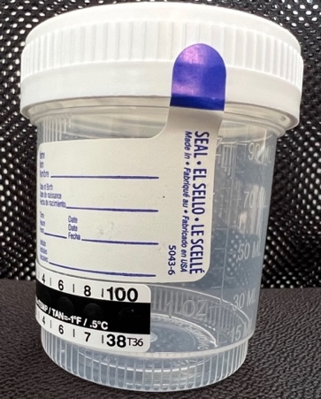 SAMPLE B

STEP 1: Open (break sterile seal) specimen cup A in competitor’s presence and give to him/her.

STEP 2: Competitor provides a urine sample filling the collection cup A at least 2 fluid ounces

STEP 3: Complete all of the marked areas on the sample form

Date
Date
Urine Collector’s Signature
Athlete’s Signature
Athlete’s First & Last Name
XX
XX
Collector’s signature
Date
Date
Athlete signature
First and Last Name

STEP 4: Open a second urine collection container in front of the athlete.

STEP 5: Ask the athlete to watch as you pour half of their original sample (aka: SAMPLE A) onto the 2nd container (SAMPLE B). Explain that this sample can be tested if the athlete fails SAMPLE A.

STEP 6: Seal both containers so the cap is on straight and tight.
STEP 7: Peel the “A Vial” label from the paperwork and place it over top of the collection container SAMPLE A so that the PLACE OVER CAP circle in directly on top of the container’s cap.

STEP 8: Peel the “B Vial” label from the paperwork and place it over top of the collection container SAMPLE B so that the PLACE OVER CAP circle in directly on top of the container’s cap.

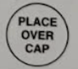

BIOHAZARD BAG INSTRUCTIONS:

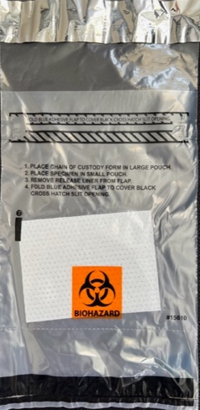
STEP 9:
Ask the competitor to place BOTH of their specimen cups in the main pocket of the small plastic bag labeled BIOHAZARD pictured on the right

STEP 10:
The PINK COPY of the collection form goes to the LAB, fold it, and place it in the outer pocket of the BIOHAZARD bag of that competitor.

STEP 11:
Seal the bag and have the competitor place it in the larger plastic bag provided.

STEP 12: Give the competitor the YELLOW COPY of the form to keep for their records.

STEP 13: Give the promoter the WHITE COPY of the form to keep for their records.

STEP 14: After the event, all urine samples are placed in the large clear plastic bag, along with the PINK copies of the forms in the smaller bags, then the clear bag is placed in the FedEx bag.

** IMPORTANT PAPERWORK **
YELLOW COPY – Athlete
WHITE COPY – Promoter
PINK COPY - Lab

STEP 15: SHIP TO SMRTL:

SPORTS MEDICINE RESEARCH & TESTING LABORATORY
10644 SOUTH JORDAN GATEWAY
SOUTH JORDAN, UTAH
84095-4022

QUESTIONS OR CONCERNS:
Text or Call Marjorie (757) 969-8762

